Email Signature Program Design Checklist
This will typically be completed by, or with the collaboration of, someone in the marketing department.

This form is designed to provide us with some preliminary ideas as to where you want to go with your email signature program.

Please note that changes (additions / deletions) to the signature content are extremely easy to execute, so do not get stressed over your responses here. If you change your mind about anything as this process proceeds, we will gladly make the adjustment(s) that you desire.

Part 1 – How will the signatures be managed?
☐ Sync to our active directory will provide basic data (email address, name, title, phone number, etc.) and users will be able to add additional data as needed
☐ Sync to our active directory will provide basic data (email address, name, title, phone number, etc.). One or more designated email signature program managers will add additional data, as required, for users. Users will never be able to directly edit their signatures.
☐ Users will add their data directly via the user portal (email address, name, title, phone number, etc.). No sync to active directory will be established.
☐ One or more designated email signature program managers will add user data directly via the manager’s dashboard. No sync to active directory will be established and users will never be able to directly edit their signatures.

Part 2- What core items would you like included in your email signatures?

E-mail Address
☐ We want the email address spelled out in the signature
☐ Do not include the email address in the signature – people can just click reply

Name
☐ Make “name” a required field (this is the standard approach)
☐ Allow for a signature without a person’s name (to meet special circumstances)

Professional Credentials / Certifications
☐ Include “Professional Credentials / Certifications“ as an option for users
☐ Do not include this option

Job Title / Role
☐ Required (this is standard)
☐ Optional
☐ Do not include title in the signature

Location
☐ Include location (address) in the signature (selected from a drop-down location menu)
☐ Allow users to enter their own (custom) address
☐ Allow users to skip the display of a location (for “work from home” people)
☐ Do not include location (address) in the signature

Telephone
☐ Required
☐ Optional

Extension
☐ We use telephone extensions
☐ We do not need to include an option for telephone extensions

Mobile
☐ Include an option for people to add their mobile number

Include Disclaimer / Confidentiality Statement
☐ Require the inclusion of a disclaimer / confidentiality statement
☐ Make the inclusion of a disclaimer / confidentiality statement optional
☐ We do not use a disclaimer / confidentiality statement

Our standard disclaimer / confidentiality statement is:
This email may contain confidential and/or private information. If you received this email in error please delete and notify sender.

☐ Use our standard disclaimer / confidentiality statement
☐ We have our own disclaimer / confidentiality statement we’d like used. (Please attach your disclaimer / confidentiality statement as text (so we can copy it) when returning this form.)
☐ Not applicable – we won’t be using a disclaimer / confidentiality statement

Part 3 – What secondary would you like to have included in your email signatures?

Photo
☐ Require the inclusion of the user’s photo
☐ Optionally allow for the inclusion of the user’s photo
☐ We will not include user photos in the signatures

Closing Salutation (Sincerely, Kid regards, Best wishes, etc.)
☐ Allow users to add their own preferred closing salutation
☐ Do not provide an option for a closing salutation

Preferred Pronouns
☐ Allow users to add their own preferred pronouns (typed in)
☐ Allow users to select preferred pronouns from this list:
he / him
she / her
they / them
☐ Do not provide an option for preferred pronouns

Fax
☐ Include an option for fax number
☐ Do not include an option for fax number

Personal LinkedIn URL
☐ Allow users to include a link to their personal LinkedIn URL in their signature
☐ Do not allow users to include a link to their personal LinkedIn URL in their signature

Bio URL (bio page on website)
☐ Allow users paste in a bio page URL from our website to include “bio” in their signature
☐ Do not allow

"Schedule a Meeting" URL
☐ Allow inclusion of a calendar URL to include “schedule meeting ” link in their signature
☐ Do not allow

Include Social Media Icons
☐ Allow users to toggle social media icons ON / OFF in their signature
☐ Do not allow

User Entered Note (often used to announce upcoming personal time off, etc.)
☐ Allow users to enter a personalized note at the bottom of their signature
☐ Do not allow

Part 4 – Do you have other content needs?

The email signature program is (almost) infinitely flexible. Therefore, we can accommodate just about any need or desire you may have. Some examples form over the years include:
- option to include state or nationally required license numbers
- link to an online catalog
- link to a “donate here” page on your website
- link to a pronunciation site (for users with hard to pronounce names)
- addition of award graphics (Best Place to Work, etc.)
- link to “careers” page in your website
- option to include multiple addresses
- option to include assistant’s name, phone and email address
- and really anything else you can think of…

Please include a description of any additional content / features that you’d like to have included in your program when you return this questionnaire.
Part 5 – Do you want to utilize more streamlined email signatures for replies and internal messages?

This diagram illustrates the concept:
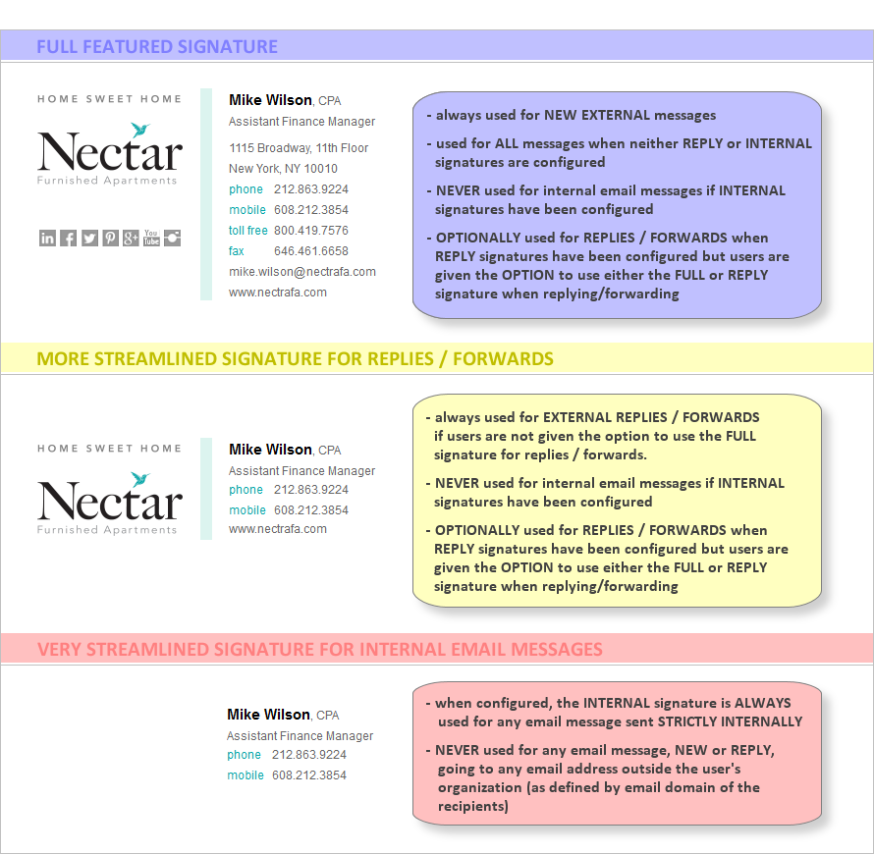

Check one, both, or none, of these two options.
☐ We’d like to include the option for a streamlined signature for replies / forwards
☐ We’d like to utilize a super streamlined signature for internal messages

